

THE UNIVERSITY OF AZAD JAMMU AND KASHMIR, MUZAFFARABAD
Department of Software Engineering

Submitted to: | Engr. Sidra Rafique
Course Title: | Operating System
Course Code: | CS-2105
Session: | 2024-2028
Lab No: | 02
Roll No: | 2024-SE-15
Submitted By: | Shahzad Ahmed Awan
Submission date: | October 25, 2025

Table of Contents
Operating System Lab 2 – Windows CMD 3
Lab Objective: 3
Execution of Windows CMD Commands: 3
Command 1: ipconfig 3
Command 2: ping 4
Command 3: tasklist 5
Command 4: cd 5
Command 5: dir 6
Command 6: echo My name > file.txt 7
Command 7: fc 8
Command 8: rename 9
Command 9: del 10
Command 10: tree 11
Command 11: mkdir 12
Command 12: rmdir 12
Theoretical Questions and Explanations 13
Lab Conclusion: 15

Table of Figures
Figure 1: Command-1 Output Screenshot 3
Figure 2: Command-2 Output Screenshot 4
Figure 3: Command-3 Output Screenshot 5
Figure 4: Command-4 Output Screenshot 6
Figure 5: Command-5 Output Screenshot 7
Figure 6: Command-6 Output Screenshot 8
Figure 7: Command-7 Output Screenshot 9
Figure 8: Commad-8 Output Screenshot 10
Figure 9: Command-9 Output Screenshot 10
Figure 10: Command-10 Output Screenshot 11
Figure 11: Command-11 Output Screenshot 12
Figure 12: Command-12 Output Screenshot 13

Operating System Lab 2 – Windows CMD

Lab Objective:
The objective of this lab is to understand and execute fundamental Command Prompt (CMD) commands in Windows. Through this activity, students will learn how to navigate directories, manage files, monitor network connectivity, and perform basic system operations using the command-line interface. This will help in developing practical skills for system management and troubleshooting.

Execution of Windows CMD Commands:

Command 1: ipconfig
Purpose:
Displays the current IP configuration of your system, including IP address, subnet mask, and default gateway.
Explanation:
- Shows all active network adapters and their configurations.
- Useful for troubleshooting internet and local network connectivity.
- Provides DNS, DHCP, and physical (MAC) address details when used with /all.
Command Used:
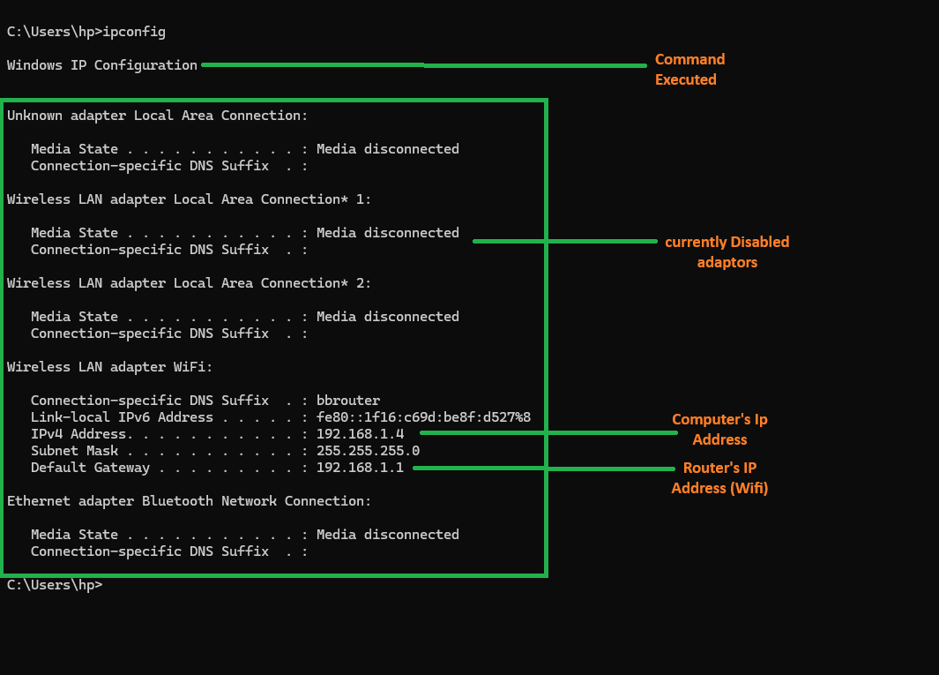
Ipconfig
Figure 1: Command-1 Output Screenshot
Output Explanation:
Displays IPv4 and IPv6 addresses, default gateway, and subnet mask for each network adapter.

Command 2: ping
Purpose:
Tests network connectivity between your computer and another device or website.
Explanation:
- Sends small data packets (ICMP Echo Requests) to the target.
- Measures response time to determine connection quality.
- Useful for verifying if a website or IP address is reachable.
Command Used:
ping www.google.com
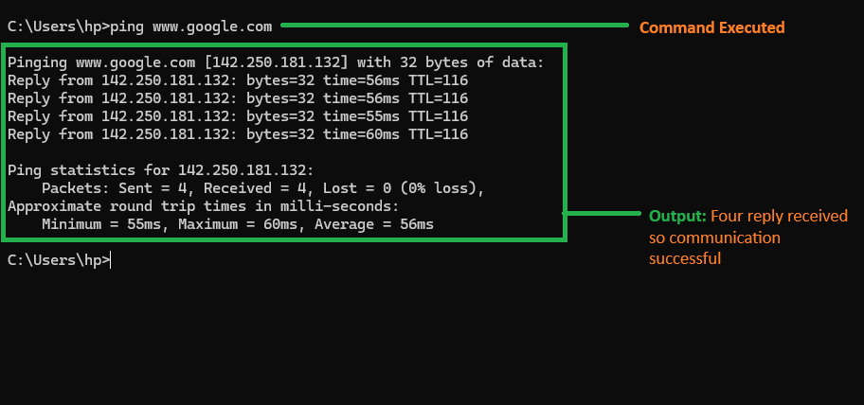
Figure 2: Command-2 Output Screenshot
Output Explanation:
Displays the time (in milliseconds) each packet took to travel, along with packet loss statistics.

Command 3: tasklist
Purpose:
Displays all currently running programs and background processes.
Explanation:
- Lists process names, IDs (PIDs), session names, and memory usage.
- Helps identify which programs are using the most system resources.
- Useful for monitoring or troubleshooting performance issues.
Command Used:
tasklist
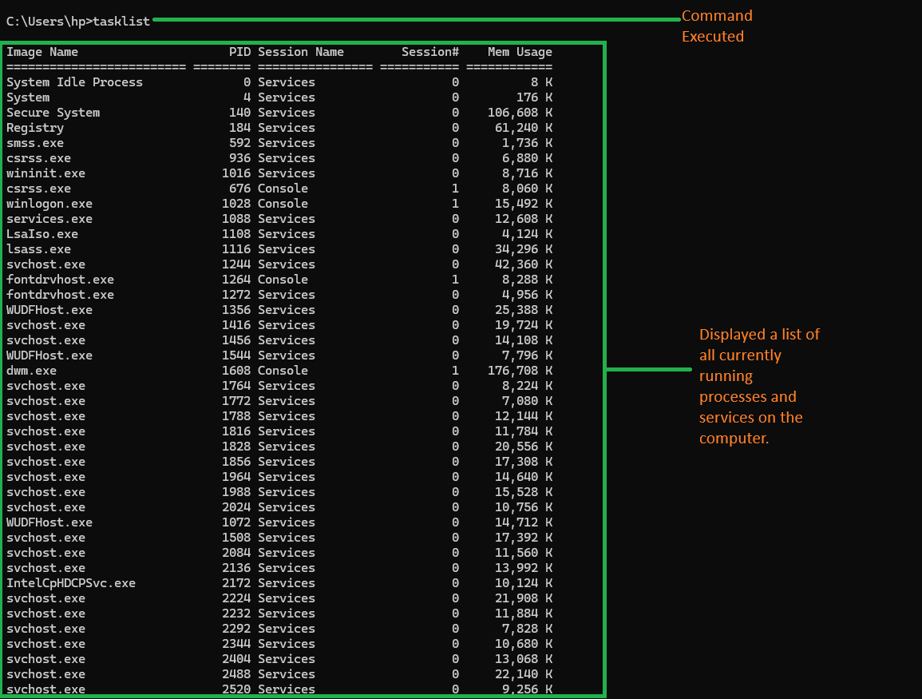
Figure 3: Command-3 Output Screenshot
Output Explanation:
Shows all active processes running on the system, including applications and services.

Command 4: cd
Purpose:
Used to navigate between directories (folders) in the file system.

Explanation:
- cd foldername moves into a specific folder.
- cd .. moves up one directory level.
- Helps organize file operations efficiently.
Command Used:
cd Important
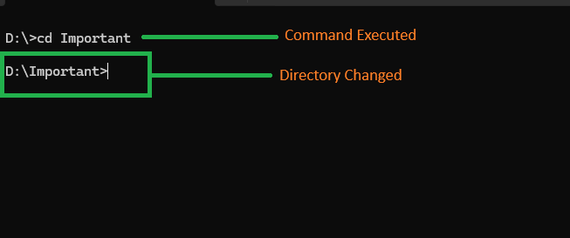
Figure 4: Command-4 Output Screenshot
Output Explanation:
Changes the current directory path, which is shown before the command prompt cursor.

Command 5: dir
Purpose:
Lists all files and folders in the current directory.
Explanation:
- Displays filenames, sizes, and modification dates.
- Helps verify which files exist before performing file operations.
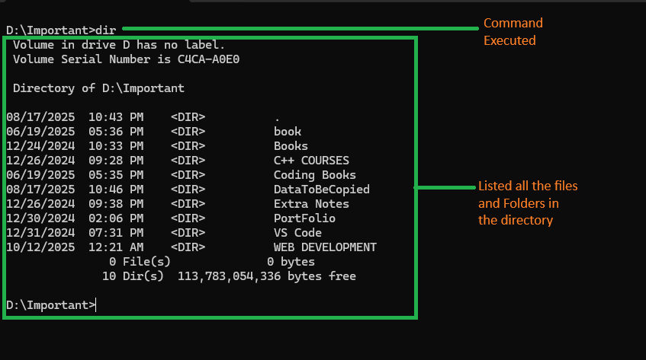
- Can use /p to pause per screen or /w for wide listing.
Figure 5: Command-5 Output Screenshot

Command Used:
dir
Output Explanation:
Shows a detailed list of contents in the current directory, including folders and files.

Command 6: echo My name > file.txt
Purpose:
Creates a new text file and writes content to it.
Explanation:
- echo displays text or messages.
- > operator redirects output to a file (creating or overwriting it).
- Commonly used in automation or for creating log files.

Command Used:
echo My name > file1.txt
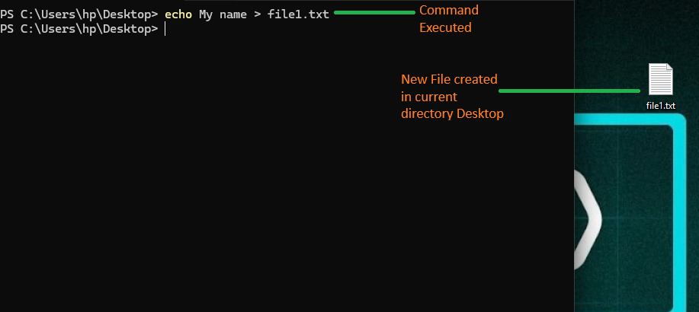
Figure 6: Command-6 Output Screenshot
Output Explanation:
Creates a new file named file1.txt containing the text “My name.”

Command 7: fc
Purpose:
Compares the contents of two text files line by line.
Explanation:
- Highlights differences between files.
- Useful for code comparison or verifying file changes.
- Shows which lines differ and where.
- Here file1.txt and file2.txt will be compared

Command Used:
fc file1.txt file2.txt
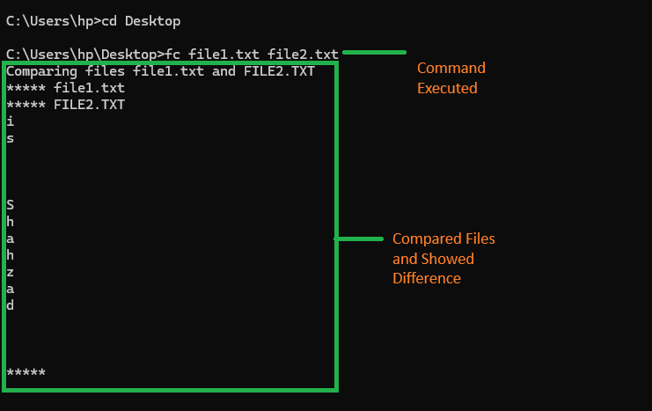
Figure 7: Command-7 Output Screenshot

Output Explanation:
Displays all differing lines between the two files, helping identify modifications.

Command 8: rename
Purpose:
Renames a file or folder.
Explanation:
- Helps in organizing files properly.
- Syntax: rename oldname newname.
- Does not affect file content, only the name.

Command Used:
rename file2.txt name.txt
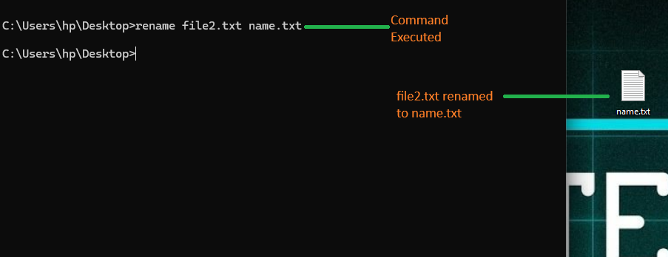
Figure 8: Commad-8 Output Screenshot
Output Explanation:
Changes the filename to name.txt in the same directory.

Command 9: del
Purpose:
Deletes a file permanently from the system.
Explanation:
- Removes specified files from the current directory.
- Supports wildcards like *.txt to delete multiple files.
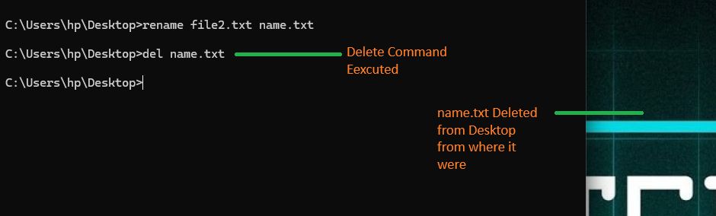
- Does not send files to Recycle Bin.
Figure 9: Command-9 Output Screenshot
Command Used:
del name.txt
Output Explanation:
Deletes the specified file and confirms successful removal in CMD.

Command 10: tree
Purpose:
Displays the folder structure of a drive or directory in a graphical tree-like format.
Explanation:
- Shows all directories and subdirectories hierarchically.
- Helps visualize folder organization.
- Adding /f also lists files within each directory.
Command Used:
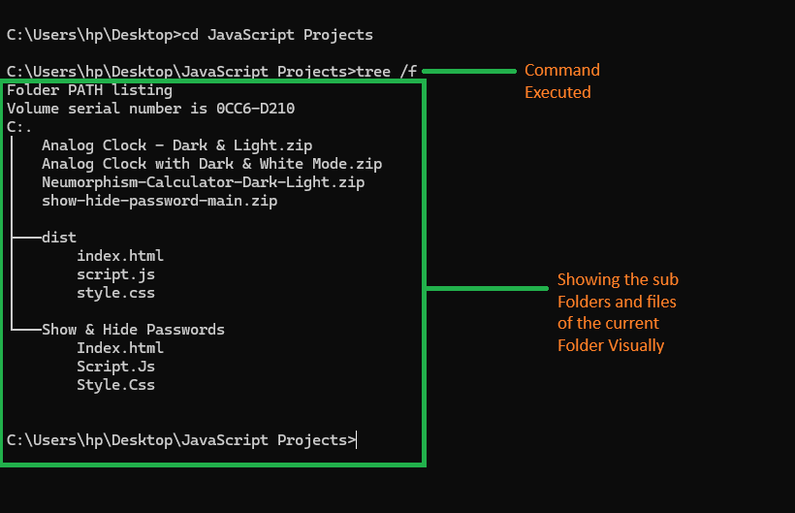
tree
Figure 10: Command-10 Output Screenshot
Output Explanation:
Displays a structured view of directories and subdirectories on the screen, giving a clear folder hierarchy.

Command 11: mkdir
Purpose:
Creates a new directory (folder).
Explanation:
- Used to organize files by grouping them into folders.
- You can also create nested folders using the full path.
- Example: mkdir Projects\Lab2 creates both folders if they don’t exist.
Command Used:
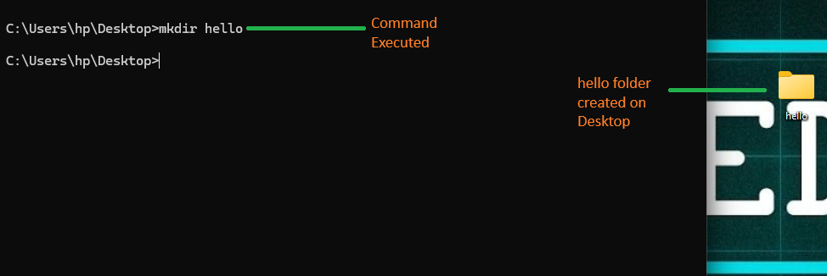
mkdir hello
Figure 11: Command-11 Output Screenshot
Output Explanation:
Creates a new folder named project in the current directory.

Command 12: rmdir
Purpose:
Removes (deletes) a directory.
Explanation:
- rmdir foldername deletes an empty folder.
- Use /s /q to delete a folder and all its contents quietly.
- Must be used carefully, as deletion is permanent.

Command Used:
rmdir hello
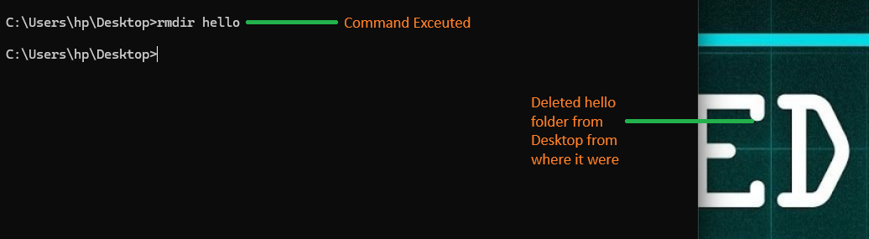
Figure 12: Command-12 Output Screenshot
Output Explanation:
Deletes the folder project if it is empty.

Theoretical Questions and Explanations

Q1) What is the purpose of the Command Prompt in Windows?
The Command Prompt serves as a command-line interpreter in Windows that allows users to interact directly with the operating system. It is used to execute commands that perform tasks such as file management, system configuration, and network troubleshooting. It provides more control and flexibility compared to the graphical user interface.

Q2) Describe the steps to open Command Prompt as an Administrator.
- Click on the Start Menu and type “cmd” in the search bar.
- Right-click on Command Prompt from the search results.
- Select “Run as Administrator” from the context menu.
- A User Account Control (UAC) window may appear; click “Yes” to grant permission.
This opens the Command Prompt with administrative privileges, allowing the execution of system-level commands.
Q3) Explain the function of ten commands you executed.
- ipconfig: Displays the network configuration details of your system such as IP address, subnet mask, and default gateway.
- ping: Tests the connectivity between your computer and another device or server on a network.
- tasklist: Shows all currently running processes on the system, including their process IDs and memory usage.
- cd: Changes the current directory, allowing you to navigate between folders.
- dir: Lists all files and subdirectories within the current directory.
- echo: Displays a message or writes text into a file.
- fc: Compares two files and displays the differences between them.
- rename: Changes the name of an existing file or folder.
- del: Deletes one or more files permanently from the specified directory.
- tree: Displays the folder structure of the current drive or directory in a hierarchical format.
- mkdir: Creates a new directory or folder in the specified location.
- rmdir: Removes an empty directory from the system.

Q4) Which command is used to list active network connections and their ports?
This command displays all active network connections along with their associated ports, protocols, and IP addresses. It helps in monitoring open connections and identifying potential security issues or active communications between devices.

Q5) What information does the whoami /all command display?
It provides detailed information about the current logged-in user, including username, domain, privileges, and security identifiers (SIDs). It is often used for auditing and verifying user access rights in a Windows environment.

Q6) How can you check your Windows version using CMD? Write the command and explain the output.
This command displays the version of the Windows operating system, along with build number and internal version details. It helps in verifying system compatibility or identifying the exact OS version when troubleshooting.
Q7) What precautions should be taken when running commands with administrative privileges?
Running commands with administrative privileges should be done carefully, as such commands can make permanent changes to the system. It is important to:
- Ensure you understand what the command does before executing it.
- Avoid deleting or modifying system files.
- Run elevated commands only when absolutely necessary.
- Always keep backups of important data to prevent accidental loss.

Lab Conclusion:
This lab provided hands-on experience with essential Windows Command Prompt (CMD) commands that are widely used for system navigation, file management, and network troubleshooting. By executing and analyzing each command, I gained a clearer understanding of how CMD interacts with the operating system at a deeper level. The exercise improved my confidence in using the command-line interface for performing real-life administrative and operational tasks efficiently. Overall, this practical exposure reinforced my foundational knowledge of operating systems and system-level control through CMD.

